Activity Monitor displays information about current SQL Server processes and how these processes affect the current instance of SQL Server. Activity Monitor is mainly for monitoring of SQL Server with respect to databases and their queries and other measures to help understand what is impacting SQL Server at the current time.  This can help you troubleshoot issues as well as see how SQL Server is using server resources.

How to Access Activity Monitor in SSMS

To open Activity Monitor right click on the SQL Server instance name and click Activity Monitor. As you can see below, there are several types of information you can review such as processes, resource waits, expensive queries, etc.

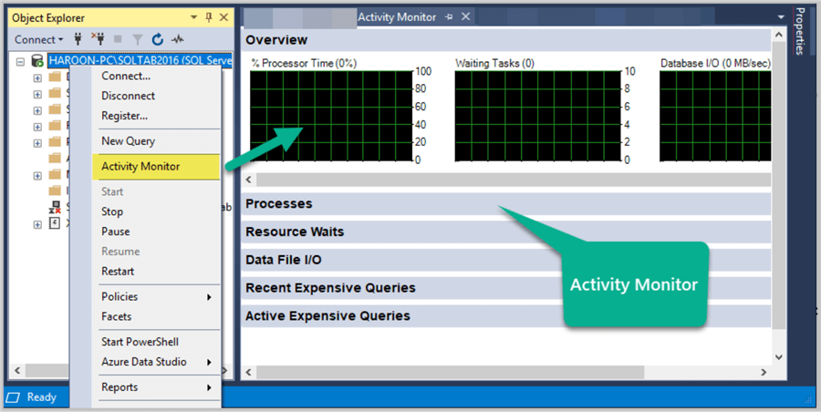

Overview: - This shows the graphical display of Processor Time (%), Number of Waiting Tasks, Database I/O (MB/Sec) and the Number of Batch Requests/second.

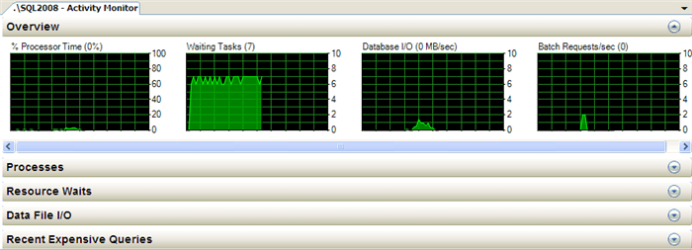

Processes: - This shows the list of all the active users which are connected to SQL Server Database Engine. Here, you can right click any of the Session IDs which you think are problematic and can run a SQL Server Profiler Trace to capture all its activities; you can also see the Session Details or can even KILL a process.

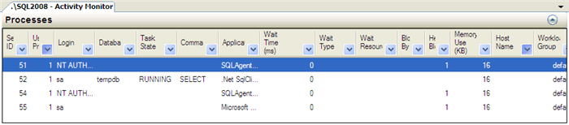

Resource Waits: - This provides valuable information with respect to a thread which is waiting for a key resource such as Memory, CPU and Network etc on an instance of SQL Server. This helps database administrators indentify potential bottlenecks with respect to Memory, CPU, Network I/O etc.

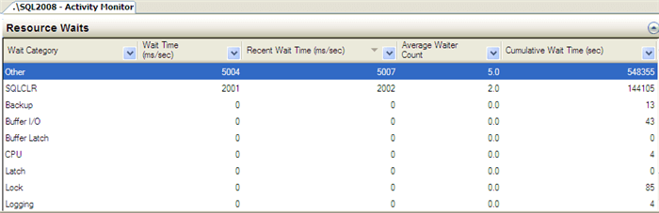

Data File I/O: - This displays disk level I/O information related to all the data and log files of user and system databases. Database administrators can quickly identify databases which are performing badly due to disk bottlenecks.

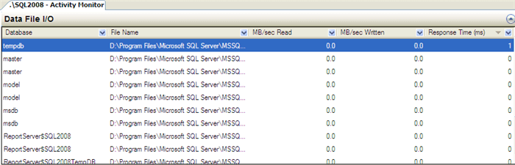

Recent Expensive Queries: - In this section, database administrators can quickly identify poorly performing queries in an SQL Server Instance. With the feature, which I like the most, you can right click any of the problematic queries and choose the "Edit Query Text" option to edit the query. Moreover, you can also see the execution plan of the poorly performing query by right clicking the problematic query and by selecting the option "Show Execution Plan".

